**TASK GUIDE (A1X.09)**

# **Objectives.**

Students know how to add drawable resource and make a Table.

1. **Requirements.**

Hardware:

* + 2 GB RAM minimum, 8 GB RAM recommended
  + 2 GB of available disk space minimum, 4 GB Recommended (500 MB for IDE + 1.5 GB for Android SDK and emulator system image)
  + 1280 x 800 minimum screen resolution
  + Intel processor with support for Intel VT-x, Intel EM64T (Intel 64), and Execute Disable (XD) Bit functionality

Software:

* + Microsoft Windows 7/8/10 (32-bit or 64-bit)
  + JDK 8
  + Android Studio IDE

1. **Resources.**

Documents:

* + Guide Supplement files:
  + header_style.xml
  + cell_style.xml Test code:
  + TestA1BasicUIX091.java
  + TestA1BasicUIX092.java

1. **Task Description.**

Student add drawable resource and start to design the interface with specified requirement and test it.

1. **Specification.**
2. Open BasicAppX project that already test passed.
3. Copy file “cell_style.xml” , “header_style.xml” and “formula.png” in Supplement folder to “drawable” folder under “res” folder.

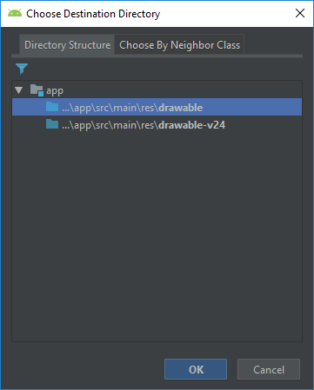

Choose “drawable” and clink OK.

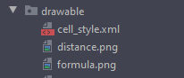

1. Open activity_main.xml file, to start UI design.
2. Under ImageView “img”, create a TableLayout with id “table” refer on the specification in specification below.

|  |  |
| --- | --- |
| **name** | **value** |
| id | table |
| layout width | wrap_content |
| layout height | wrap_content |
| layout below | @id/img |
| layout center horizontal | true |

|  |  |
| --- | --- |
| layout top margin | 5pt |
| strecth columns | * |

1. In the TableLayout tag, add 3 TableRow(s) with no properties.
2. In each TableRow(s) tag, add 1 TextView as “header” refer on the specification in specification document.

|  |  |  |  |
| --- | --- | --- | --- |
| **name** | **value** | | |
| id | tv11 | tv21 | tv31 |
| layout width | wrap_content | | |
| layout height | wrap_content | | |
| background color | @drawable/header_style | | |
| padding | 5dp | | |
| text | @string/rbTemp | @string/rbDist | @string/rbWeight |
| text color | #FFFFFF | | |
| text style | bold | | |

1. In each TableRow tag, under header textview, add 3 TextView(s) as “content” refer on the specification in specification document.

**1st Row**

|  |  |  |  |
| --- | --- | --- | --- |
| **name** | **value** | | |
| id | tv12 | tv13 | tv14 |
| layout width | wrap_content | | |
| layout height | wrap_content | | |
| background color | @drawable/cell_style | | |
| padding | 5dp | | |
| text | 0°C | 32°F | 273.15 K |

**2nd Row**

|  |  |  |  |
| --- | --- | --- | --- |
| **name** | **value** | | |
| id | tv22 | tv23 | tv24 |
| layout width | wrap_content | | |
| layout height | wrap_content | | |
| background color | @drawable/cell_style | | |
| padding | 5dp | | |
| text | 1 Meter | 39.3701 Inch | 3.2808 feet |

**3rd Row**

|  |  |  |  |
| --- | --- | --- | --- |
| **name** | **value** | | |
| id | tv32 | tv33 | tv34 |
| layout width | wrap_content | | |
| layout height | wrap_content | | |

|  |  |  |  |
| --- | --- | --- | --- |
| background color | @drawable/cell_style | | |
| padding | 5dp | | |
| text | 1 Kg | 35.2740 ounce | 2.2046 pound |

1. The result like below.

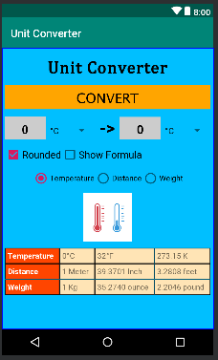

1. Under TableLayout, create an ImageView with id “imgFormula” refer on the specification below.

|  |  |
| --- | --- |
| **name** | **value** |
| id | imgFormula |
| layout width | match_parent |
| layout height | match_parent |
| src | @drawable/formula |
| layout below | table |
| layout top margin | 1pt |
| layout center horizontal | true |
| visibility | invisible |

1. Copy “TestA1BasicUIX091.java” and “TestA1BasicUIX092.java” file to “org.aplas.basicappx (test)” folder.

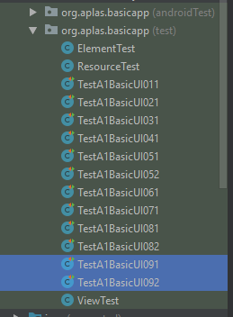

1. Right click on each test file(s) then choose Run and click it. It may take long time to execute.
2. Get the result of your task. If passed you will get green check like below. If the test failed, you will get orange check get the messages and you must start your project again.

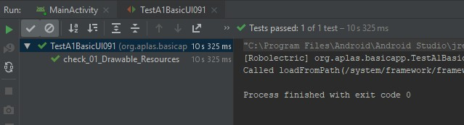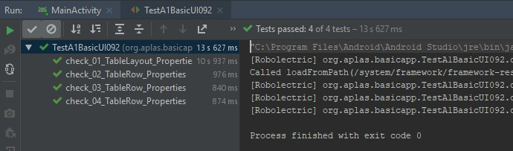

1. If all test already passed, you can run MainActivity and will be showed the UI like below

